# Quartz liner set 1: 2020 9 October - 31 December

**Visualization of the flame of thescaled Flamesheet combustor with quartz liner**

IMPORTANT NOTES:

* H_gap is assumed to be 1.5 mm throughout all experiments
* SCHUIFMAAT 1 was used to measure dimensions and distances

9 October 2020

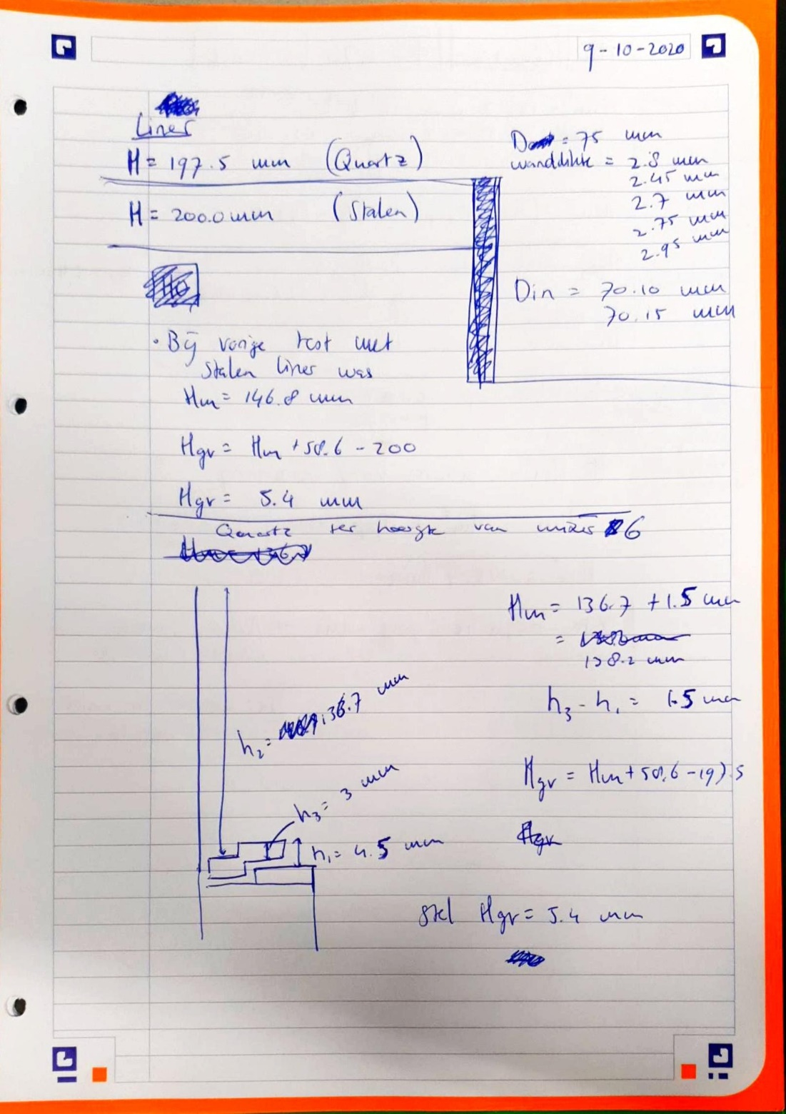

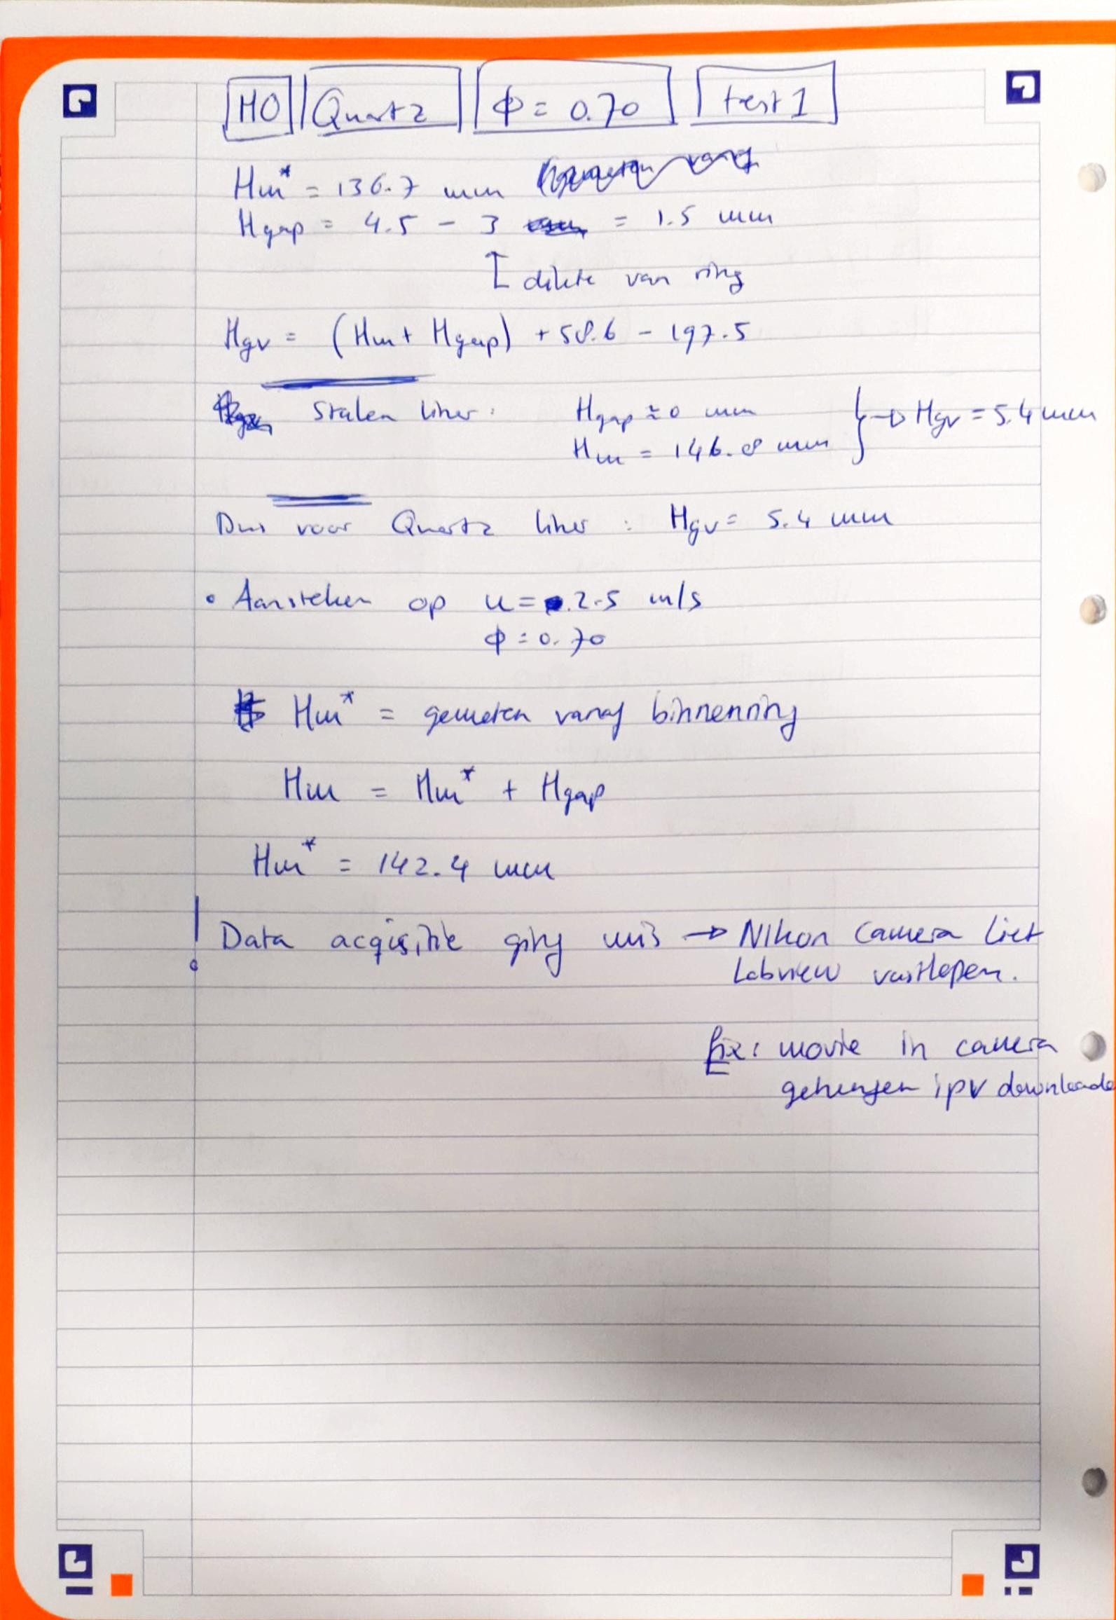

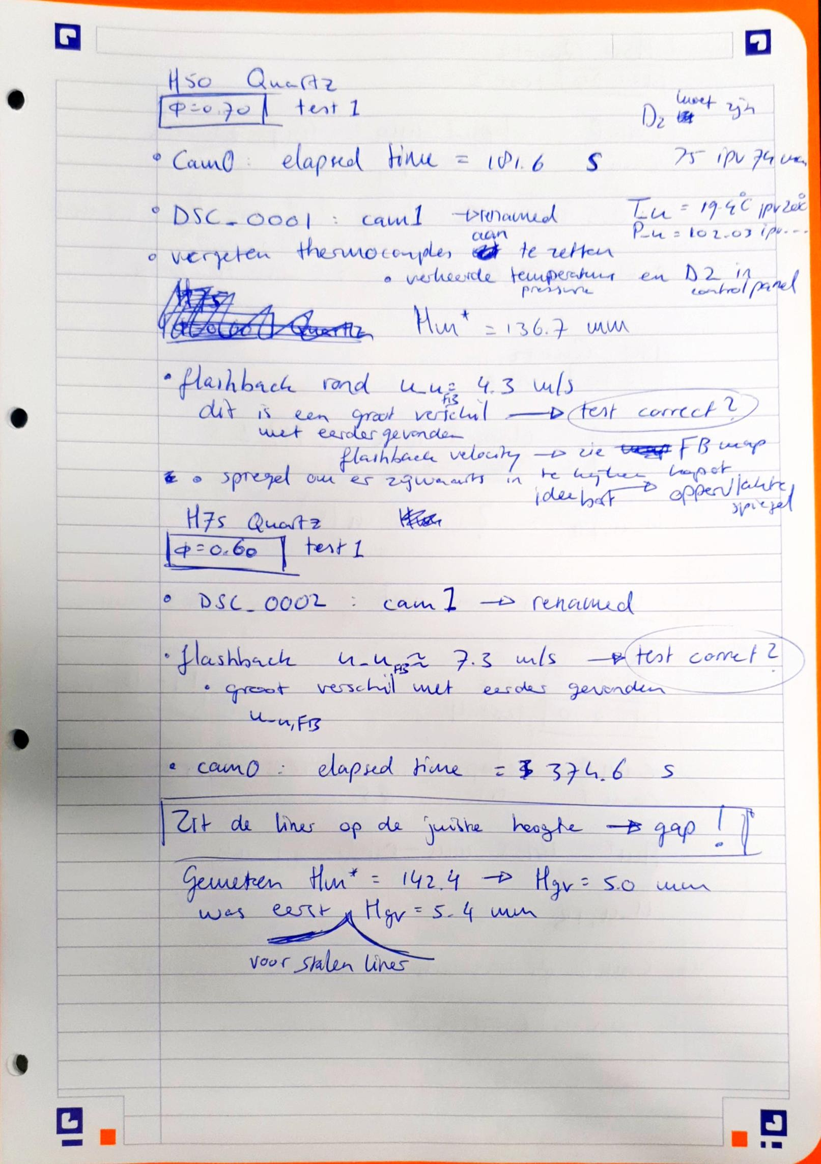

14 October 2020

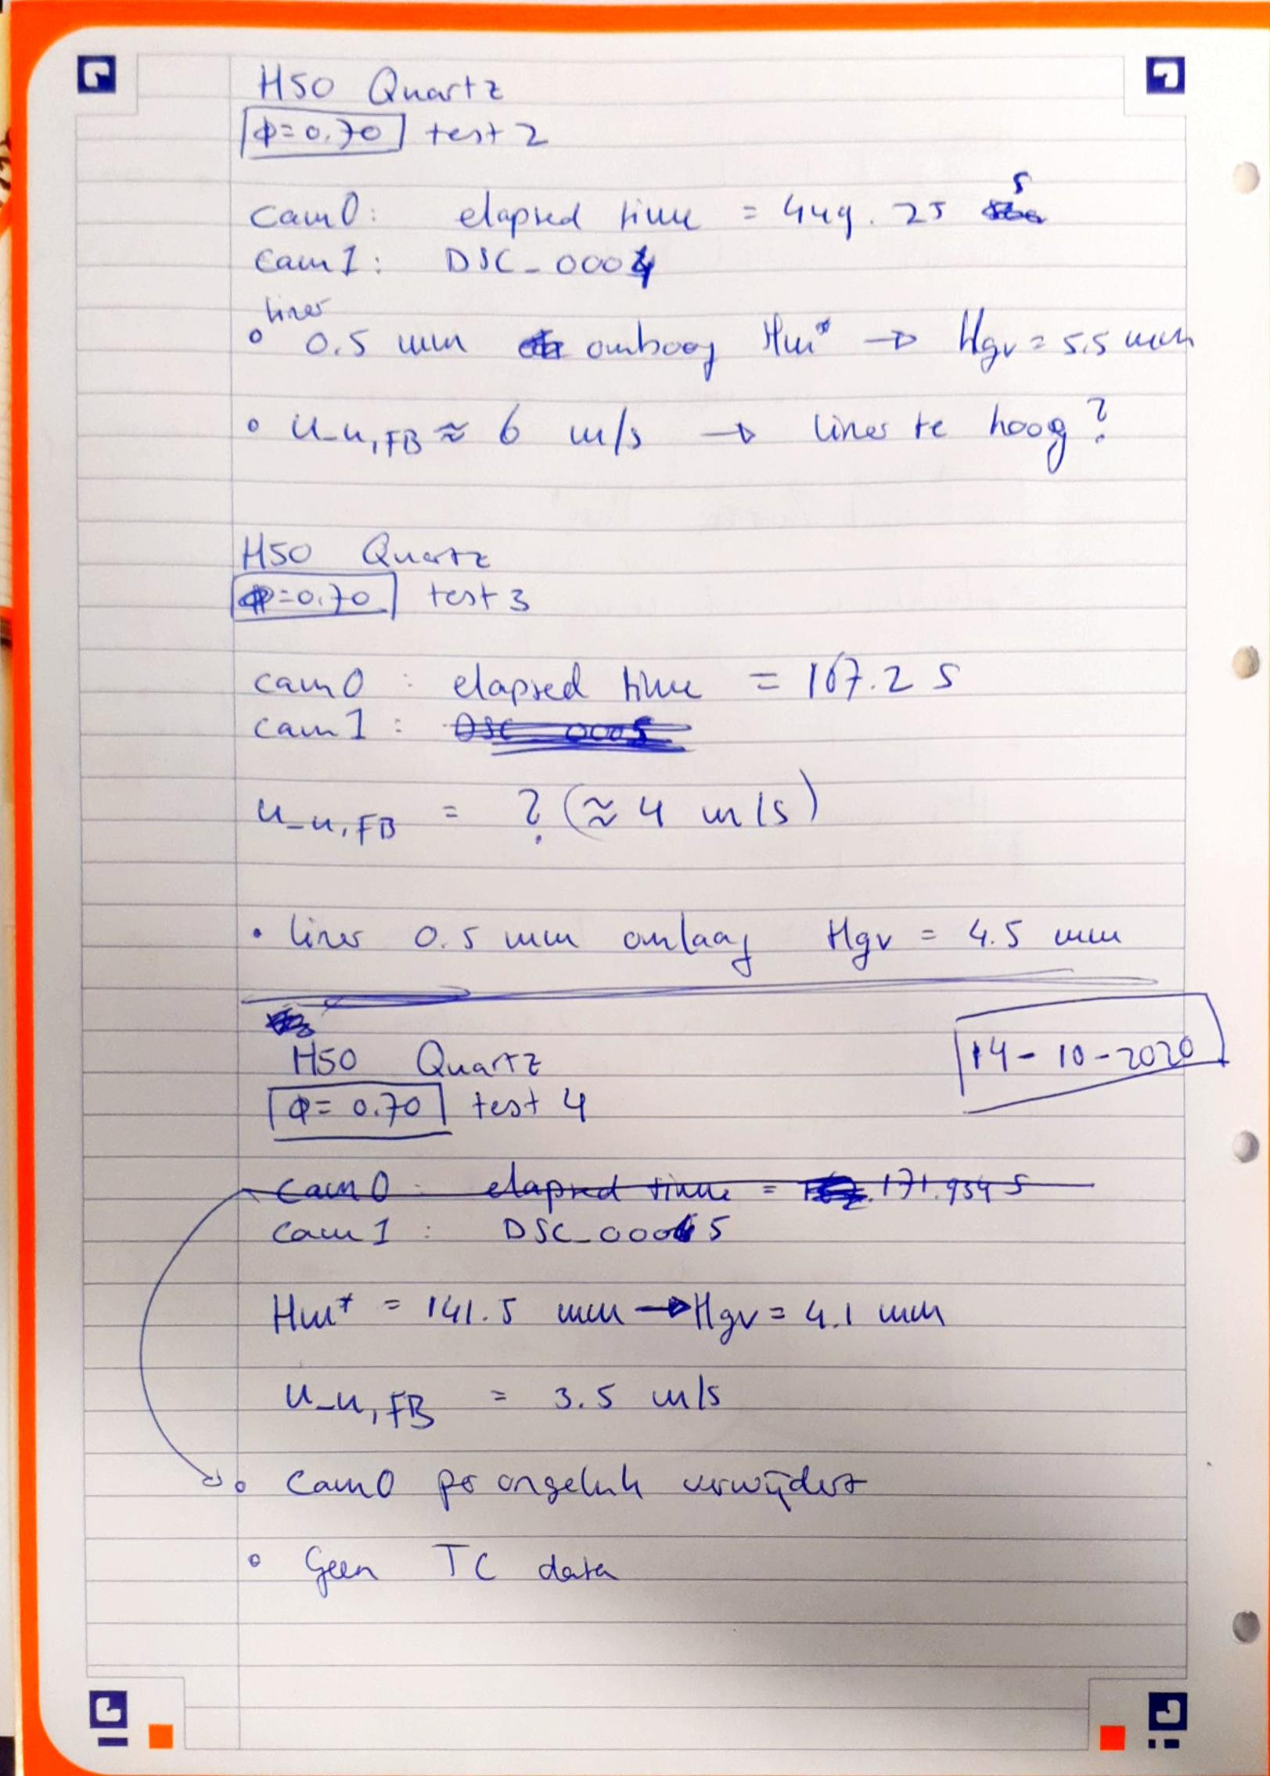

5 November 2020

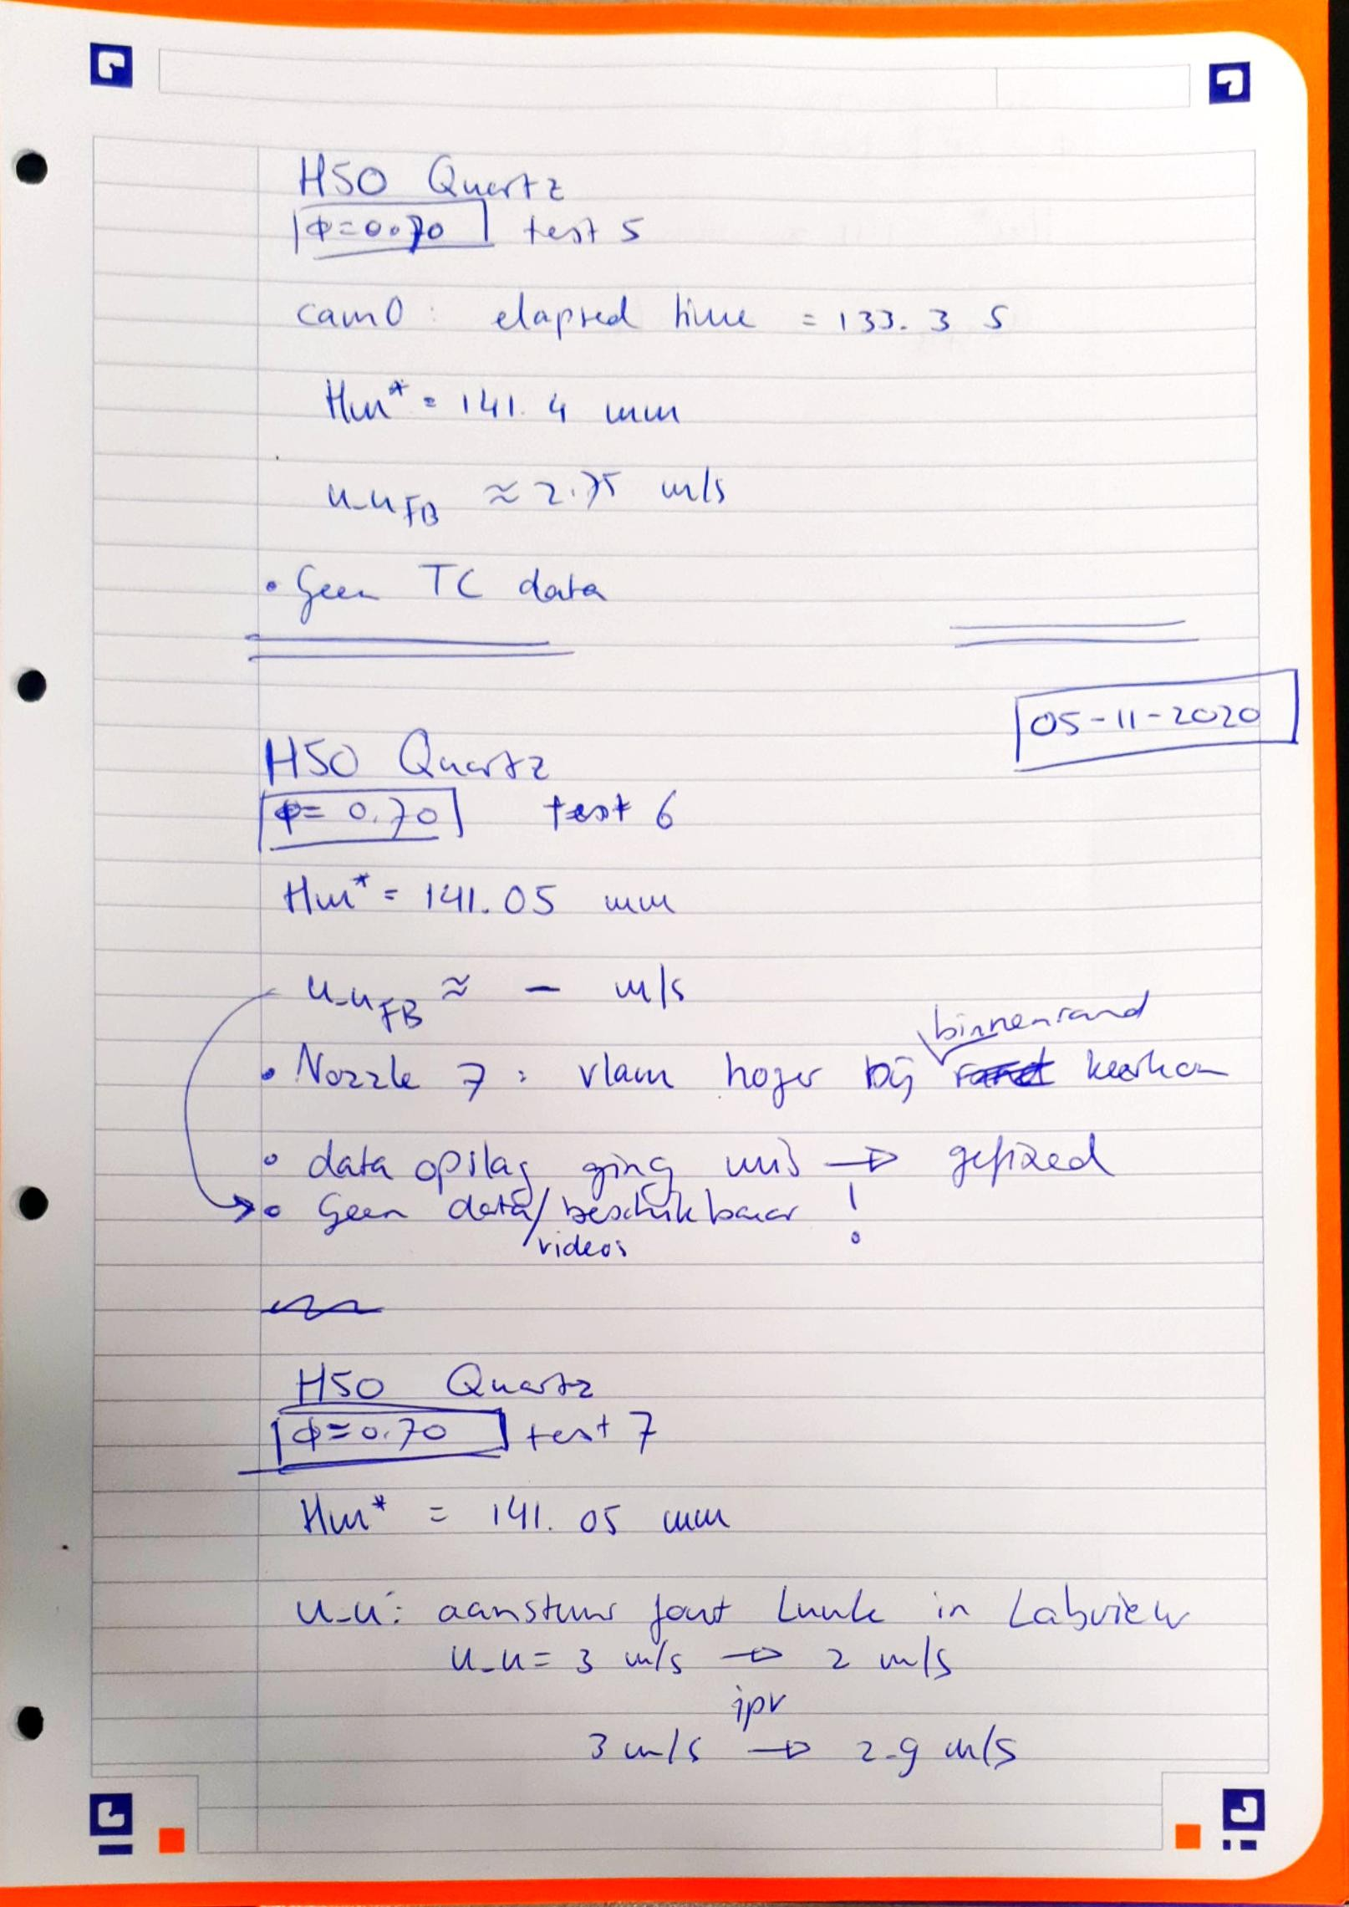

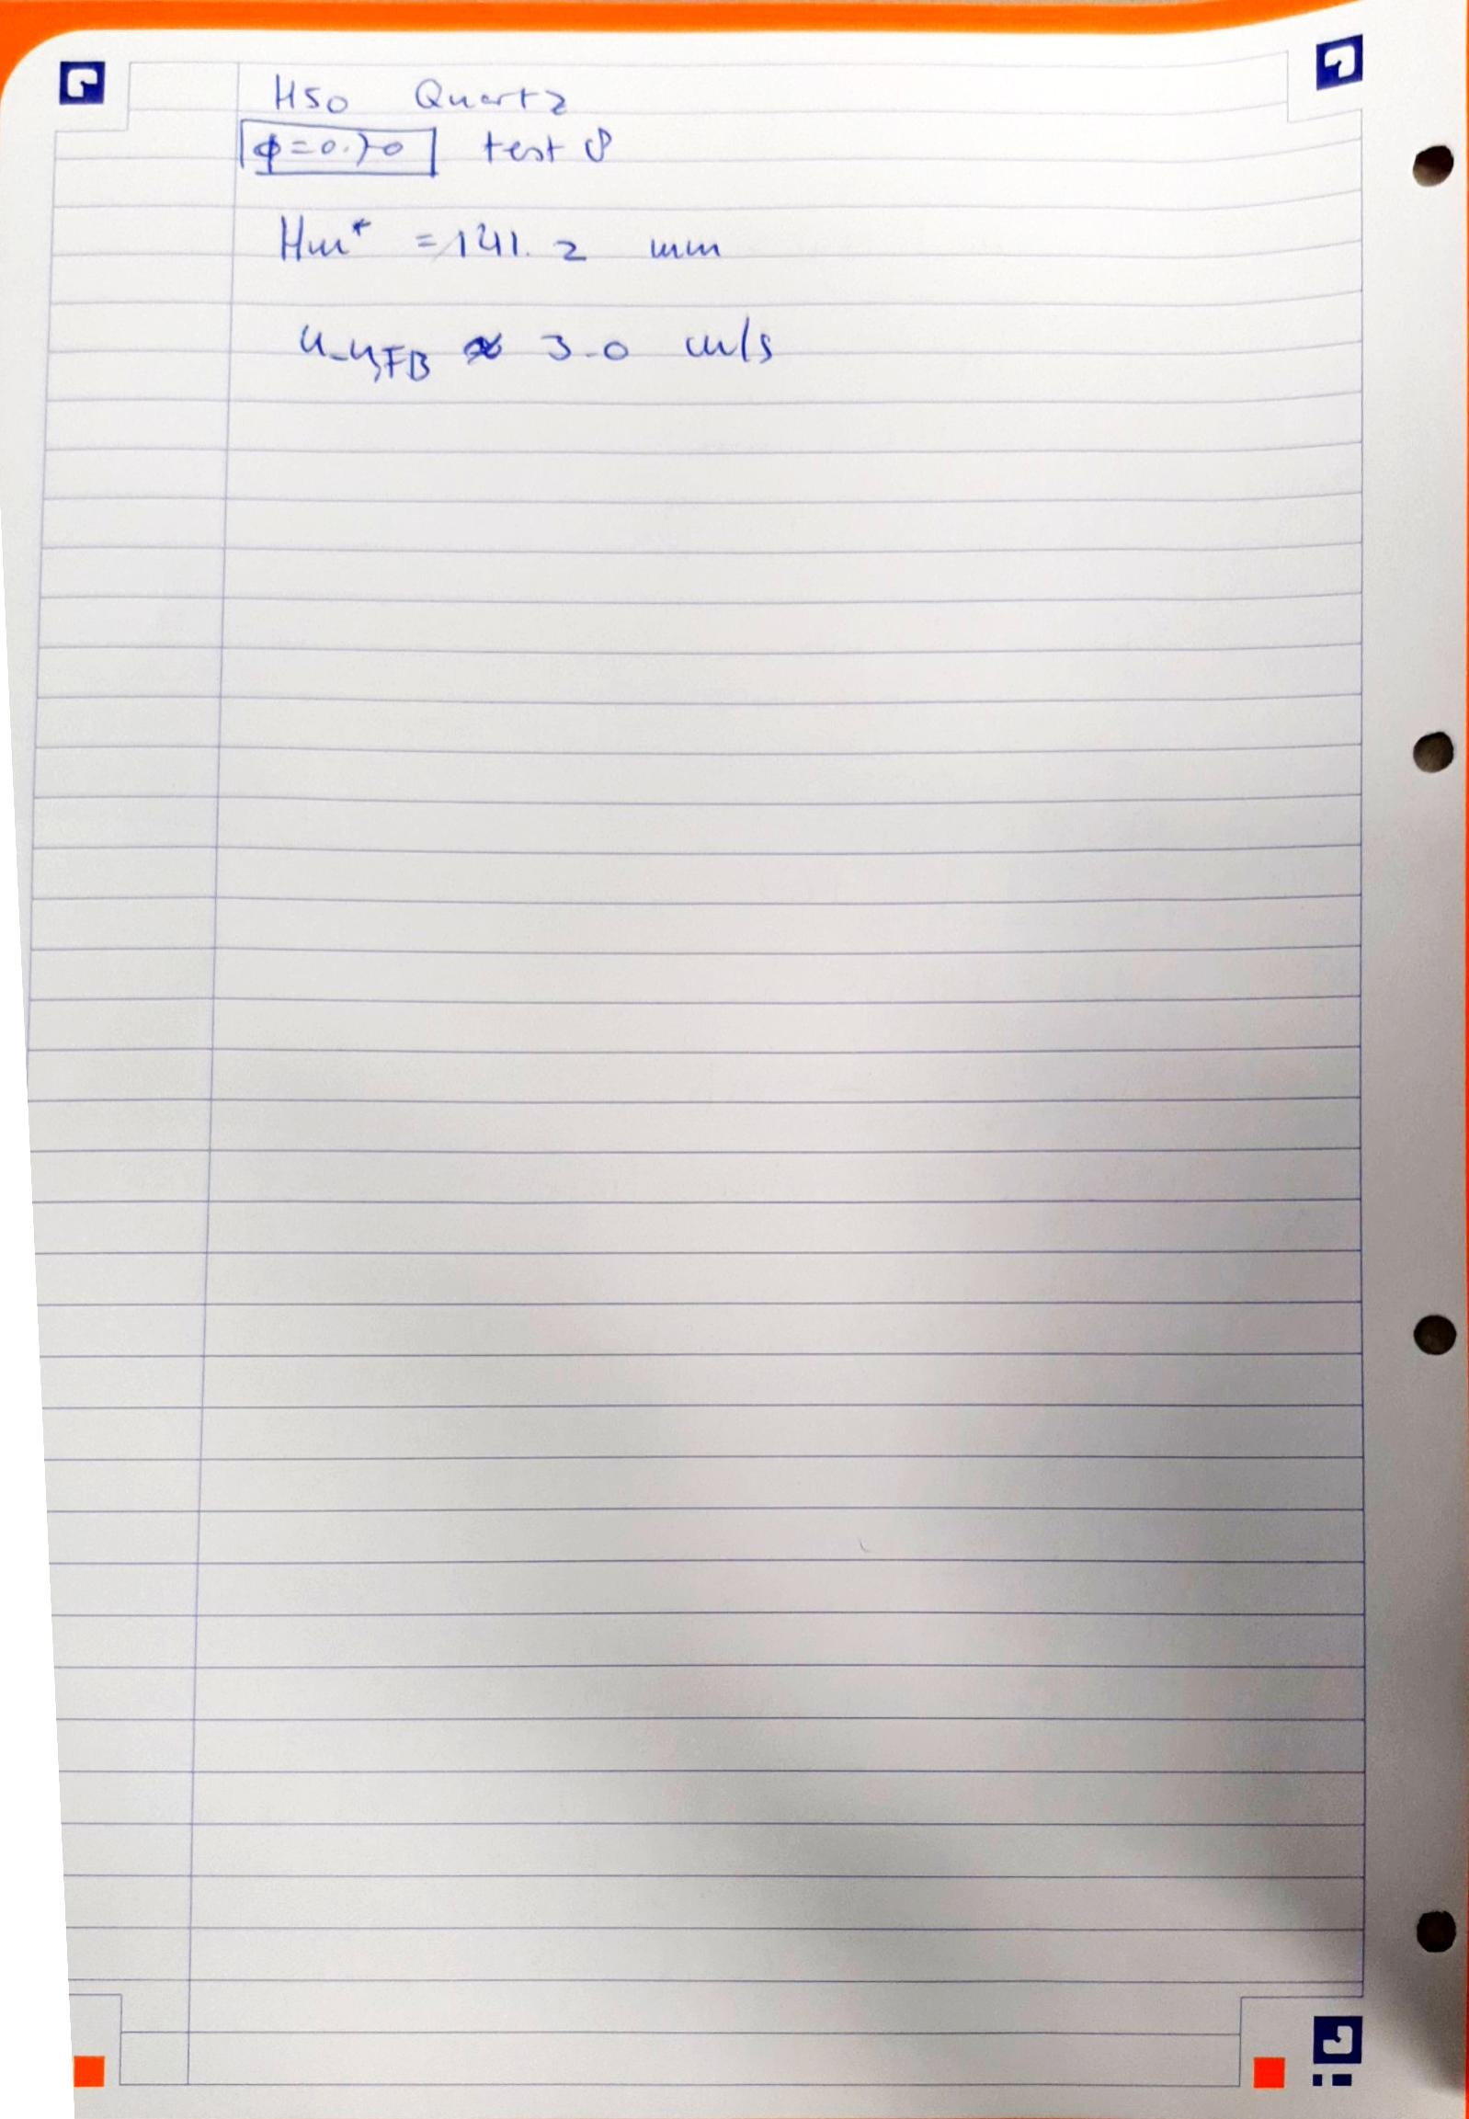

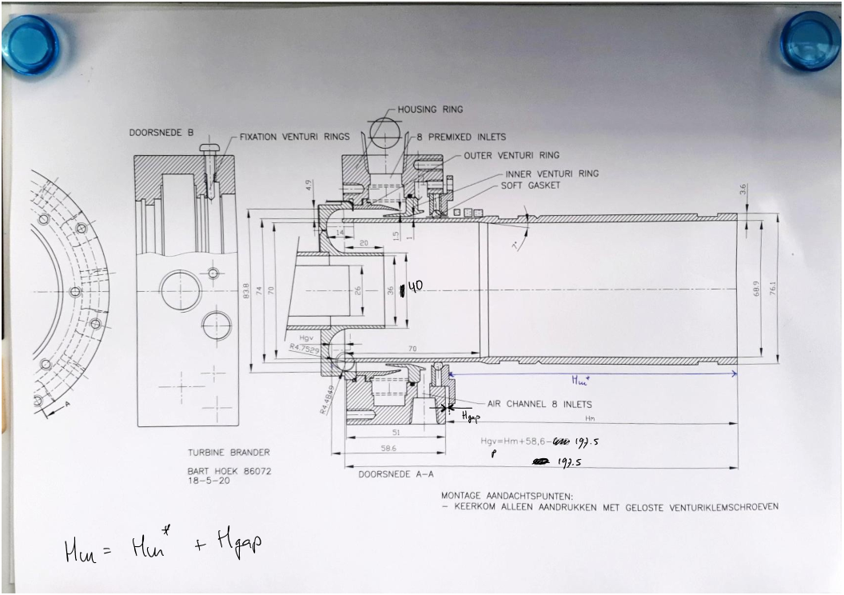

10 November 2020

**H2% = 0**

**Phi = 0.90**

**Liner: Quartz**

**Test 1**

Notes

* Hm* = 141.3 mm (gemeten ter hoogte van mixer 6)
* Video cam0:
  + Afgekapt door insufficient free physical memory
  + Overbelicht -> stalen probe niet goed zichtbaar

-----------------------------------------------------------------------------------------------------------------

**H2% = 0**

**Phi = 0.90**

**Quartz**

**Test "fooling around"**

Notes

* Hm* = 141.3 mm (gemeten ter hoogte van mixer 6)
* Geen video cam0 -> belichting checken met NI MAX

11 November 2020

**H2% = 50**

**Phi = 0.70**

**Liner: Quartz**

**Test "fooling around"**

Notes

* IMPORTANT: WAYS TO SEE WHERE THE FLAME ANCHORS

12 November 2020

**H2% = 40**

**Phi = 0.70**

**Liner: Quartz**

**Test "fooling around"**

Notes

* Demo to Ivan Langella and Georg Eitelberg from the Aerospace Department (LR):
  + 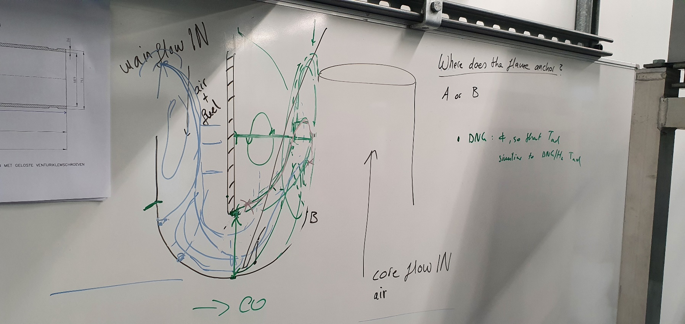Discussion regarding position/ location of the flame

25 November 2020

**H2% = 75**

**Phi = 0.70**

**Liner: Quartz**

**Test 1**

**Goal: Finding limits of combustor design regarding operating conditions**

Notes

* Hm* = 141.4 mm
* No thermocouple data (not turned on -> mistake)

27 November 2020

**H2% = 50**

**Phi = 0.70**

**Liner: Quartz**

**Test 9**

**Goal: Finding correct height of liner for flashback map**

Notes

* Hm* = 141.2 mm
* Flame detection works during normal operation, but not during flashback (still visible on the other side of the quartz glass liner).
* Gap height not measured (H_gap)

**H2% = 50**

**Phi = 0.70**

**Liner: Quartz**

**Test 10**

**Goal: Finding correct height of liner for flashback map**

Notes

* Hm* = 142.5 mm
* Flashback occurred at higher velocity than test 9
* Gap height not measured (H_gap)

**H2% = 50**

**Phi = 0.70**

**Liner: Quartz**

**Test 11**

**Goal: Finding correct height of liner for flashback map**

Notes

* Hm* = 140.6 mm
* Gap height not measured (H_gap)

**H2% = 50**

**Phi = 0.70**

**Liner: Quartz**

**Test 12**

**Goal: Finding correct height of liner for flashback map**

Notes

* Hm* = 140.0 mm
* Gap height not measured (H_gap)
* Cam0 video not complete due to Matlab memory error (!)
* Flashback velocity lowest of all test (9, 10, 11), but restricted operating range

8 December 2020

**H2% = 50**

**Phi = 0.50**

**Liner: Quartz**

**Test 1**

Notes

* Hm* = 141.2 mm (gemeten ter hoogte van mixer 6)
* Check data cam0 and mfc

-----------------------------------------------------------------------------------------------------------------

**H2% = 50**

**Phi = 0.60**

**Liner: Quartz**

**Test 1**

Notes

* Hm* = 141.2 mm (gemeten ter hoogte van mixer 6)

-----------------------------------------------------------------------------------------------------------------

**H2% = 50**

**Phi = 0.70**

**Liner: Quartz**

**Test 13**

Notes

* Hm* = 141.2 mm (gemeten ter hoogte van mixer 6)

-----------------------------------------------------------------------------------------------------------------

**H2% = 50**

**Phi = 0.80**

**Liner: Quartz**

**Test 1**

Notes

* Hm* = 141.45 mm (gemeten ter hoogte van mixer 6)

-----------------------------------------------------------------------------------------------------------------

**H2% = 50**

**Phi = 0.90**

**Liner: Quartz**

**Test 1**

Notes

* Hm* = 141.25mm (gemeten ter hoogte van mixer 6)

-----------------------------------------------------------------------------------------------------------------

**H2% = 75**

**Phi = 0.35**

**Liner: Quartz**

**Test 1**

Notes

* Hm* = 141.2 mm (gemeten ter hoogte van mixer 6)
* Flame not detected by UV sensor -> bypass UV sensor?

-----------------------------------------------------------------------------------------------------------------

**H2% = 75**

**Phi = 0.40**

**Liner: Quartz**

**Test 1**

Notes

* Hm* = 141.2 mm (gemeten ter hoogte van mixer 6)
* Flame not detected by UV sensor -> bypass UV sensor?

-----------------------------------------------------------------------------------------------------------------

**H2% = 75**

**Phi = 0.50**

**Liner: Quartz**

**Test 1**

Notes

* Hm* = 141.15 mm (gemeten ter hoogte van mixer 6)

-----------------------------------------------------------------------------------------------------------------

**H2% = 75**

**Phi = 0.60**

**Liner: Quartz**

**Test 2**

Notes

* Hm* = 141.3 mm (gemeten ter hoogte van mixer 6)
* Flashback bij toenemende u_u ?!

-----------------------------------------------------------------------------------------------------------------

**H2% = 75**

**Phi = 0.60**

**Liner: Quartz**

**Test 3**

Notes

* Hm* = 141.2 mm (gemeten ter hoogte van mixer 6)
* Flashback door opwarmen keerkom

-----------------------------------------------------------------------------------------------------------------

**H2% = 75**

**Phi = 0.60**

**Liner: Quartz**

**Test 4**

Notes

* Hm* = 141.2 mm (gemeten ter hoogte van mixer 6)

-----------------------------------------------------------------------------------------------------------------

**H2% = 75**

**Phi = 0.70**

**Liner: Quartz**

**Test 2**

Notes

* Hm* = 141.2 mm (gemeten ter hoogte van mixer 6)
* **Set parameters not achieved!**

-----------------------------------------------------------------------------------------------------------------

**H2% = 75**

**Phi = 0.70**

**Liner: Quartz**

**Test 3**

Notes

* Hm* = 141.3 mm (gemeten ter hoogte van mixer 6)
* **Set parameters not achieved!**

9 December 2020

**H2% = 75**

**Phi = 0.70**

**Liner: Quartz**

**Test 4**

Notes

* Hm* = 141.10 mm (gemeten ter hoogte van mixer 6)
* **Set parameters not achieved!**

-----------------------------------------------------------------------------------------------------------------

**H2% = 75**

**Phi = 0.70**

**Liner: Quartz**

**Test 5**

Notes

* Hm* = 141.15 mm (gemeten ter hoogte van mixer 6)
* **Set parameters not achieved!**

-----------------------------------------------------------------------------------------------------------------

**H2% = 100**

**Phi = 0.30**

**Liner: Quartz**

**Test 1**

Notes

* Hm* = 141.15 mm (gemeten ter hoogte van mixer 6)
* Flame not detected -> UV sensor relocated

-----------------------------------------------------------------------------------------------------------------

**H2% = 100**

**Phi = 0.30**

**Liner: Quartz**

**Test 2**

Notes

* Hm* = 141.2 mm (gemeten ter hoogte van mixer 6)

-----------------------------------------------------------------------------------------------------------------

**H2% = 100**

**Phi = 0.35**

**Liner: Quartz**

**Test 1**

Notes

* Hm* = 141.2 mm (gemeten ter hoogte van mixer 6)

-----------------------------------------------------------------------------------------------------------------

**H2% = 100**

**Phi = 0.40**

**Liner: Quartz**

**Test 1**

Notes

* Hm* = 141.15 mm (gemeten ter hoogte van mixer 6)
* Resonance -> "organ pipe"

-----------------------------------------------------------------------------------------------------------------

**H2% = 100**

**Phi = 0.45**

**Liner: Quartz**

**Test 1**

Notes

* Hm* = 141.2 mm (gemeten ter hoogte van mixer 6)
* -> Velocity to high?
* **Set parameters not achieved!**

-----------------------------------------------------------------------------------------------------------------

**H2% = 100**

**Phi = 0.45**

**Liner: Quartz**

**Test 2**

Notes

* Hm* = 141.7 mm **[!]** (gemeten ter hoogte van mixer 6)
* Velocity to low?
* **Set parameters not achieved!**

10 December 2020

**H2% = 100**

**Phi = 0.45**

**Liner: Quartz**

**Test 3**

Notes

* Hm* = 141.25 mm (gemeten ter hoogte van mixer 6)
* Velocity to low?
* **Set parameters not achieved!**

-----------------------------------------------------------------------------------------------------------------

**H2% = 100**

**Phi = 0.45**

**Liner: Quartz**

**Test 4**

Notes

* Hm* = 142.2 mm **[!]** (gemeten ter hoogte van mixer 6)
* **Set parameters not achieved!**

-----------------------------------------------------------------------------------------------------------------

**H2% = 100**

**Phi = 0.45**

**Liner: Quartz**

**Test 5**

Notes

* Hm* = 141.1 mm (gemeten ter hoogte van mixer 6)
* Hm* = 141.5 mm (gemeten ter hoogte van mixer 2)
* **Set parameters not achieved!**

-----------------------------------------------------------------------------------------------------------------

**H2% = 100**

**Phi = 0.45**

**Liner: Quartz**

**Test 6**

Notes

* Hm* = 140.9 mm (gemeten ter hoogte van mixer 6)
* **Set parameters not achieved!**

15 December 2020

**H2% = 100**

**Phi = 0.45**

**Liner: Quartz**

**Test 7**

**Metalen opzetstuk op liner: Thermo-acoustische verschijnselen onderdrukken**

Notes

* **Hm* niet gemeten (kan niet door metalen opzetstuk)**
* **Set parameters not achieved!**
* **Metalen opzetstuk levert niet het gewenste effect.**

16 December 2020

|  |  |  |  |  |  |  |  |
| --- | --- | --- | --- | --- | --- | --- | --- |
| **Test case** | **Timer labview (first frame)** | **Trigger time labview cam1**  **txt file (start time)** | **Trigger time python cam0**  **txt file (start time)** | **Difference Labview timer and camX [s]** | **Average 1 [s]** | **Difference cam0 and cam1 (average) [s]** | **Files** |
| **NIKON 1** | 13:58:02.278 | 13:58:02.130 | - | 0.148 | 0.16033 | 1.20233 | sync_test_2020-12-16_test1_cam1 |
| **NIKON 2** | 14:23:04.977 | 14:23:04.794 | - | 0.183 | 0.16033 | 1.20233 | sync_test_2020-12-16_test2_cam1 |
| **NIKON 3** | 14:26:17.384 | 14:26:17.234 | - | 0.150 | 0.16033 | 1.20233 | sync_test_2020-12-16_test3_cam1 |
| **ELP 1** | 14:11:23.928 | - | 14:11:25.059 | -1.131 | -1.042 | 1.20233 | sync_test_2020-12-16_test1_cam0 |
| **ELP 2** | 14:16:47.673 | - | 14:16:48.684 | -1.011 | -1.042 | 1.20233 | sync_test_2020-12-16_test2_cam0 |
| **ELP 3** | 14:21:39.189 | - | 14:21:40.173 | -0.984 | -1.042 | 1.20233 | sync_test_2020-12-16_test3_cam0 |